Index No: 249321V  
Name: HDPR Perera   
GitHub project link: <https://github.com/pramodiperera/IT5437>

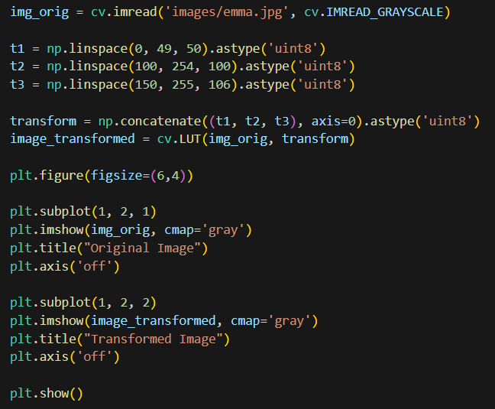**Question 01**  
Input intensity pixels are grouped as (0 – 49 , 50 – 149, 150 - 255) three ranges according to the given transformation plot.

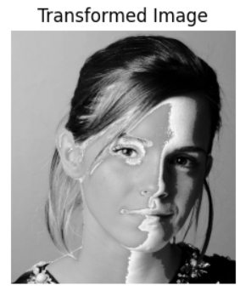

**Question 02**

1. White matter

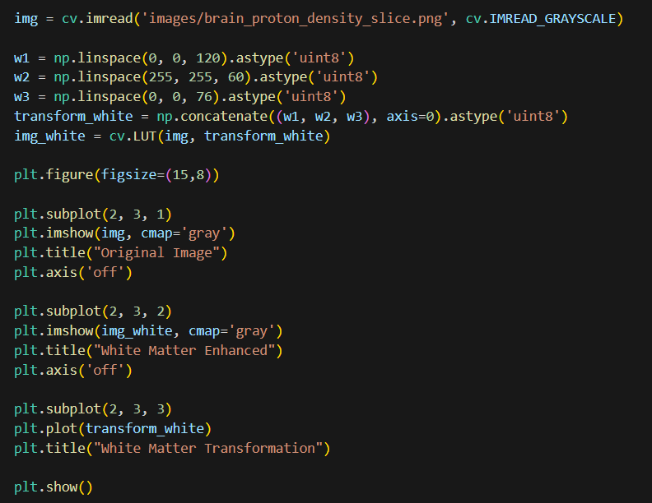According to the original image, approximately pixel intensities from 120 to 180 belongs to white matter. To accentuate white matter, it was shown in white colour (maximum intensity) and other regions were shown in black colour.

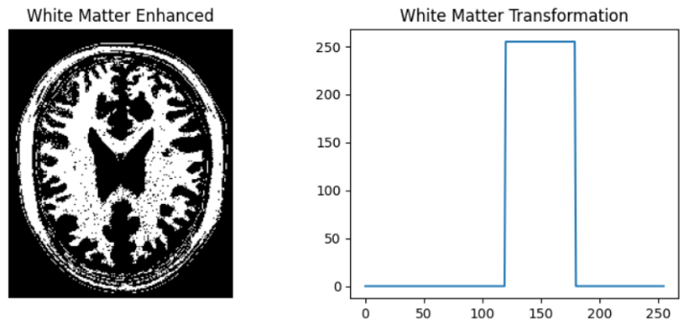

(b) Gray matter

According to the original image, approximately pixel intensities from 180 to 220 belongs to gray matter. To accentuate gray matter, it was shown in white colour (maximum intensity) and other regions shown in black colour.

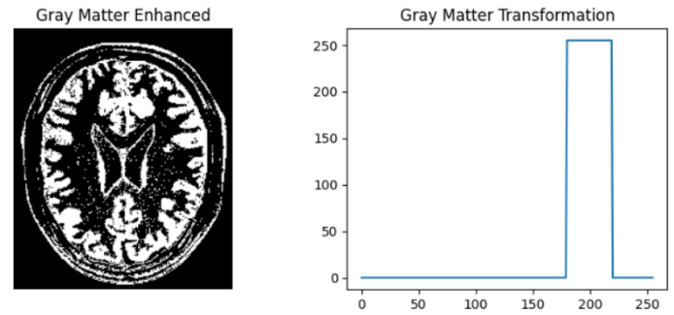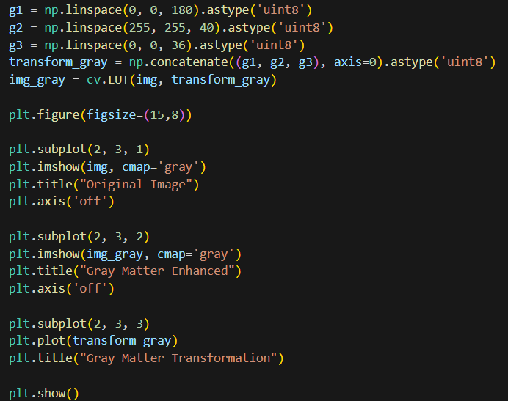

**Question 03**

The original image was converted to the LAB color space to separate the lightness channel from color information. Gamma correction was applied to the L channel with γ = 0.5. Then, the final image was regenerated by combining the adjusted L plane with the original a and b channels.

The result shows improved contrast in dark regions, which is also reflected in the shifted histogram.

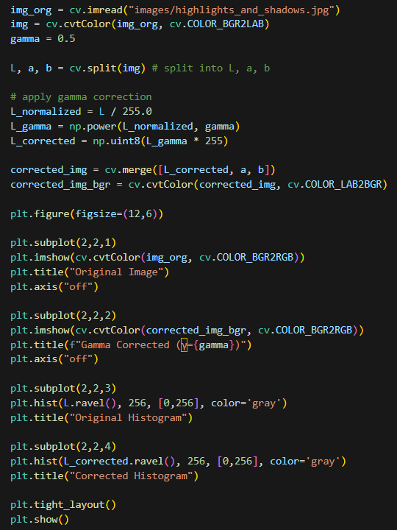

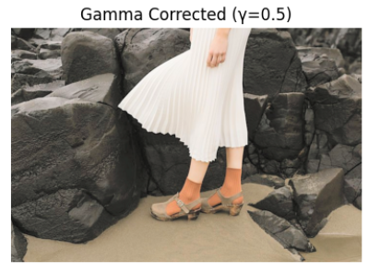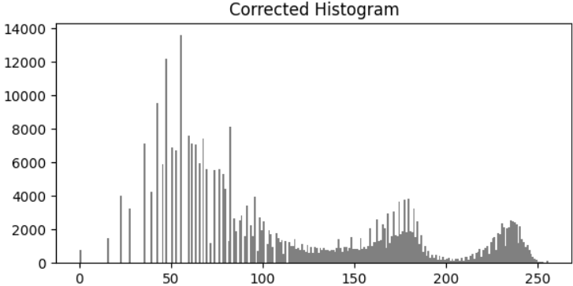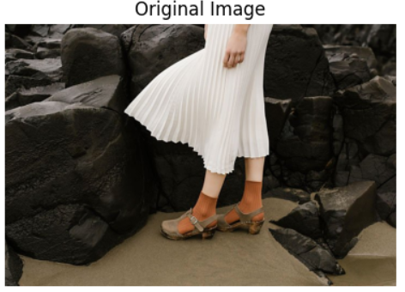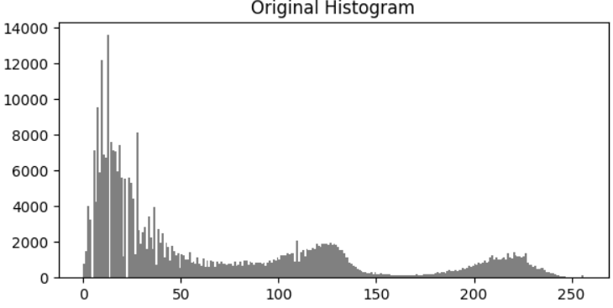

**Question 04**

Split the image into H, S, V planes. Then the given intensity transformation was applied to the saturation channel with the parameter a as 0.6 .

Final image was generated by combining the transformed saturation plane and the original H and V channels to produce a vibrance-enhanced image.

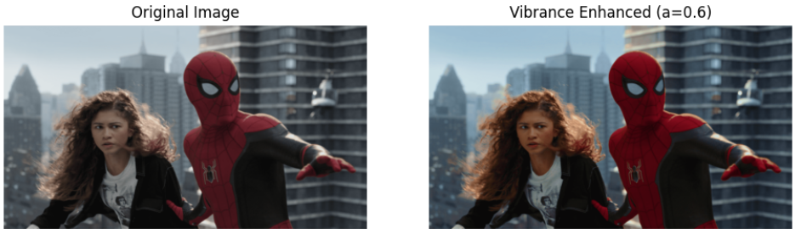 a = 0.6

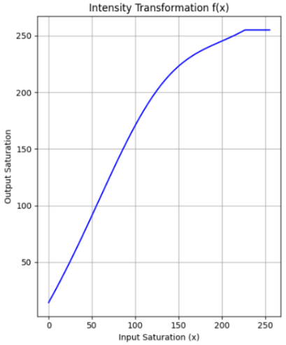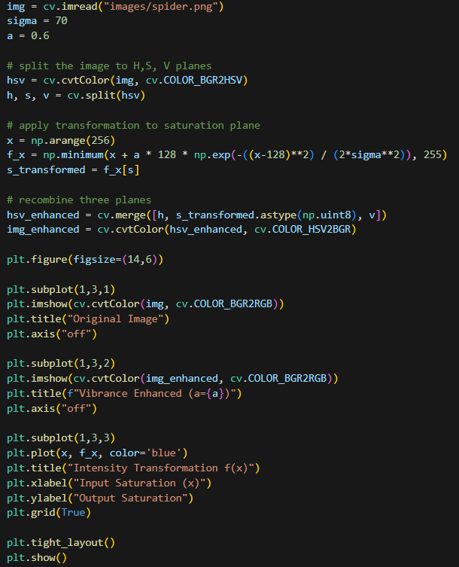

**Question 05**

Hue, saturation, and values of the image in grayscale.

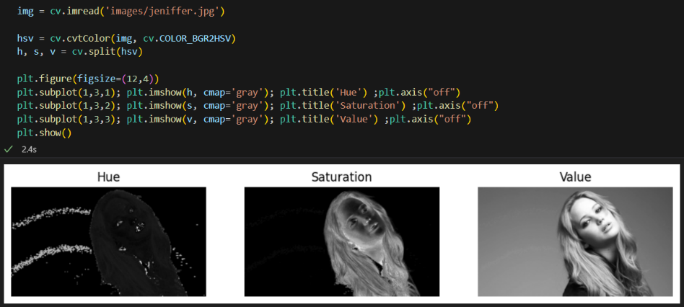

A binary mask was created by thresholding the Value channel to extract the foreground, which was then isolated using the mask.

Histogram equalization was applied only to the foreground. Then the equalized foreground was combined with the original background.

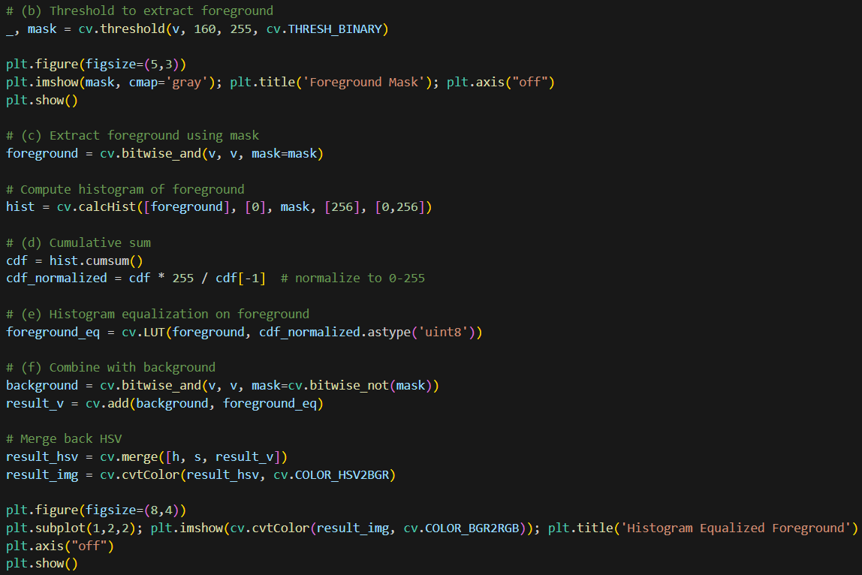

**Question 06**

1. Using the existing filter2D to Sobel filter

Additionally, magnitude was calculated by combining gradient x and gradient y.   
magnitude (i, j) = $\sqrt{{(grad_x(i, j))}^{2}+ {(grad_y(i, j))}^{2}}$

​

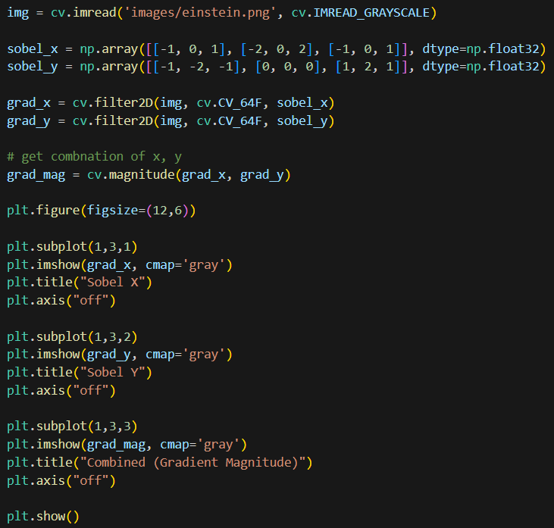

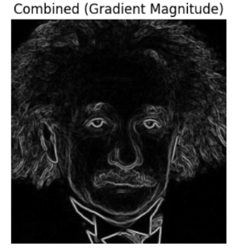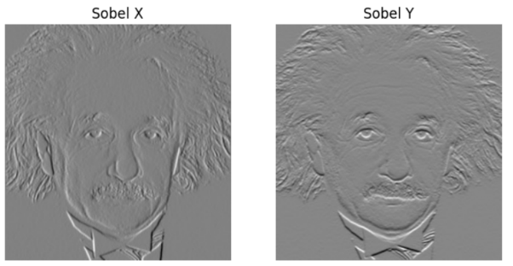

1. Using own code

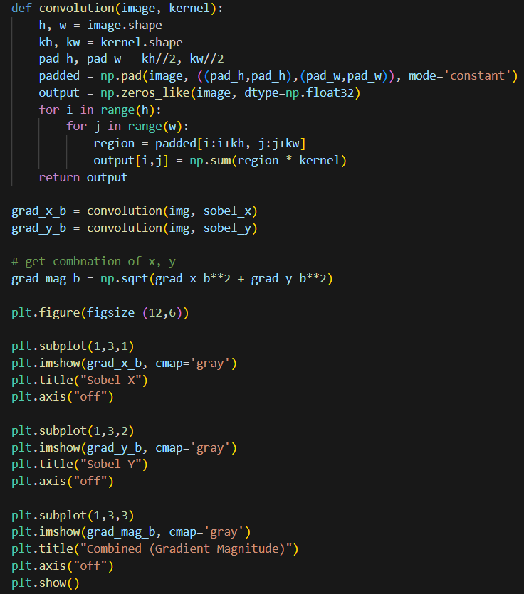

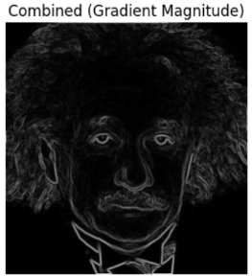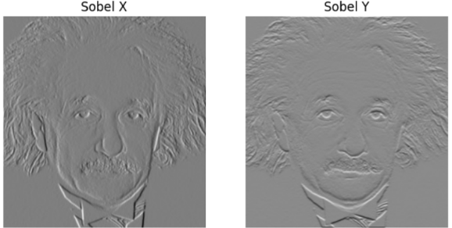

1. Using separability property

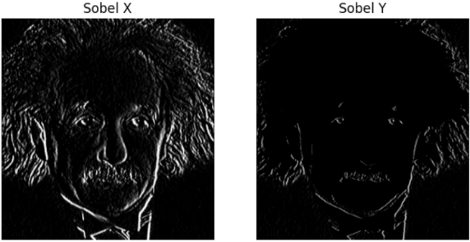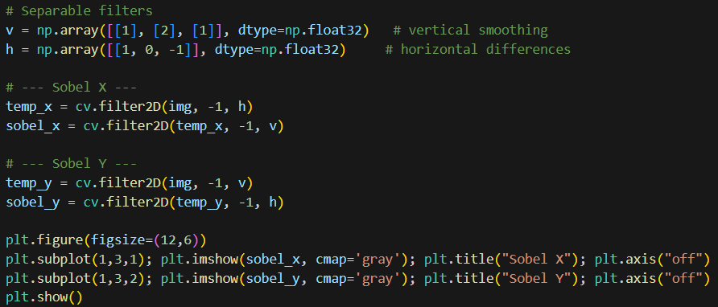The Sobel operator can be separated into a derivative filter ([1, 0, -1]) and a smoothing filter ([1, 2, 1]). This reduces the 2D convolution into two 1D steps.

**Question 07**

Left side code snippets includes functions to zoom images using nearest-neighbor, bilinear interpolation methods and find the normalized sum of squared difference (SSD). Right code snippet includes test images for zooming and calculates SSD.

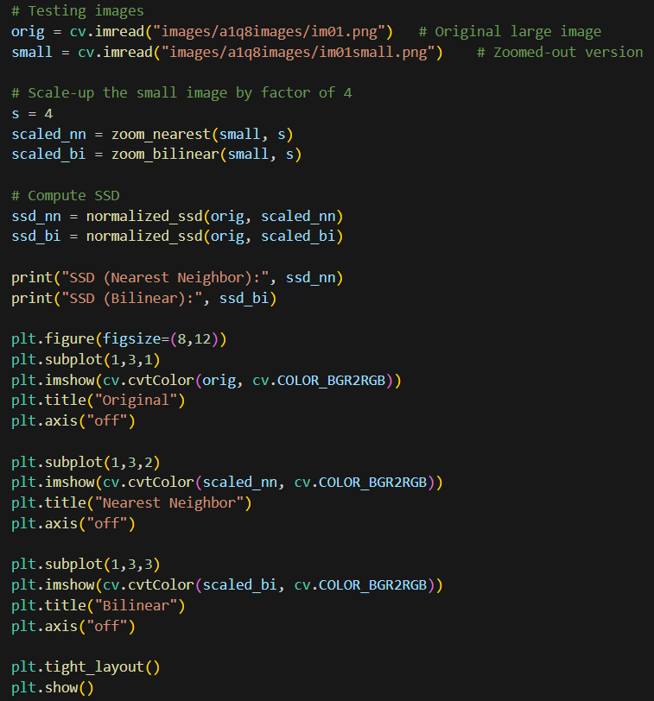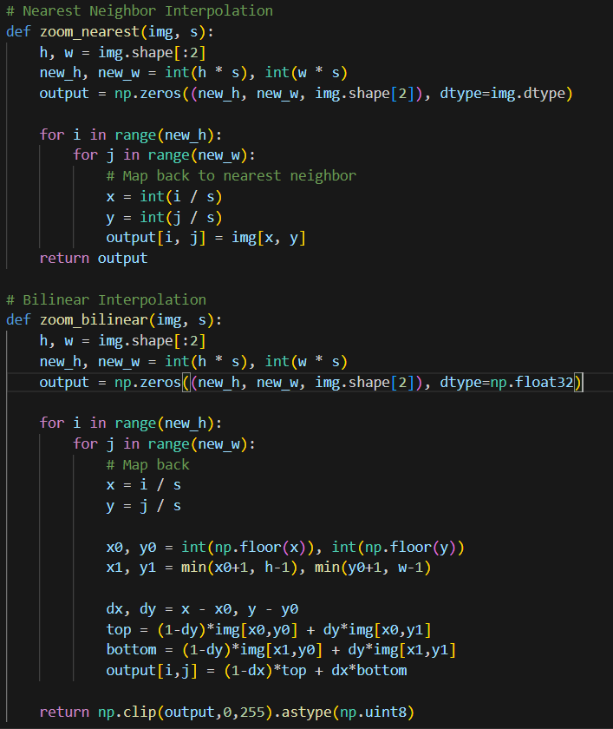

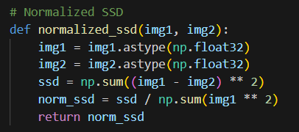

Outputs**:**

The normalized SSD values indicate how closely the upscaled images match the original.

Nearest-neighbor interpolation preserves exact pixel values but appears blocky, while bilinear interpolation produces smoother results with slightly higher error.

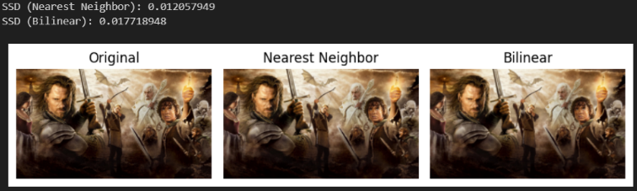

SSD (Nearest Neighbor): 0.012057949   
SSD (Bilinear): 0.017718948

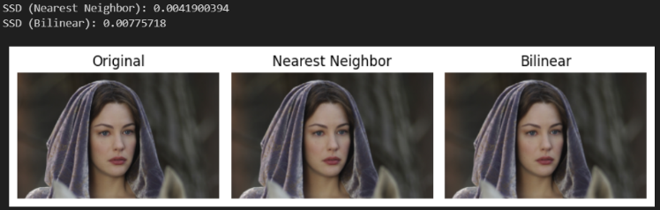

SSD (Nearest Neighbor): 0.0041900394  
SSD (Bilinear): 0.00775718

**Question 08**

1. Use grabCut to segment the image

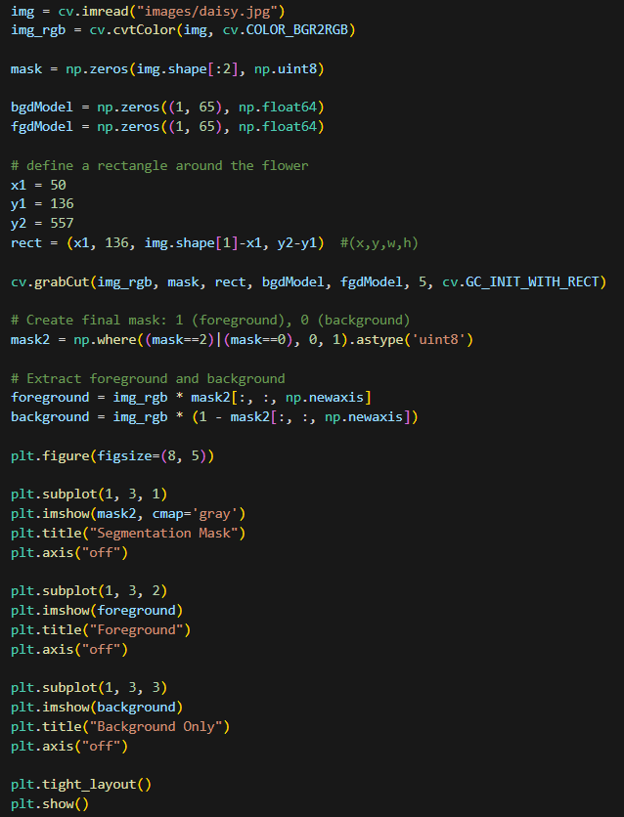The GrabCut algorithm was used with a bounding rectangle around the flower. Rectangle was defined approximately using the original image. This produced a segmentation mask, from which the foreground (flower) and background were extracted separately.

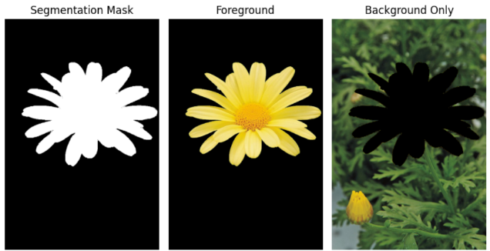

1. Produce an enhanced image with a blurred background

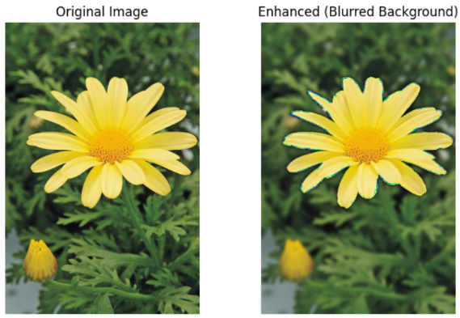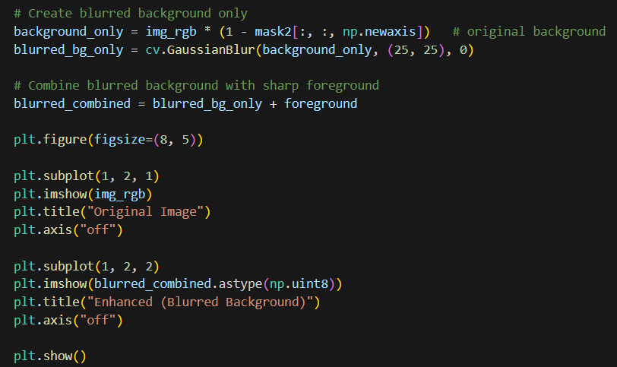To generate a blurred background, gaussian blur was applied. Then, combined blurred background and original foreground.

1. Why is the background just beyond the edge of the flower quite dark in the enhanced image?

Because Grabcut doesn’t perfectly segment the flower from its background. There can be misclassified boundary pixels. Therefore, after it combined with the blurred background, we can see a dark outline around the flower.

**Question 09**

1. 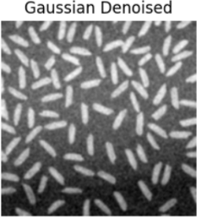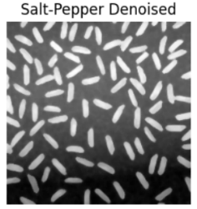and (b) Preprocess the images to remove noise. Used kernel size is as 5.

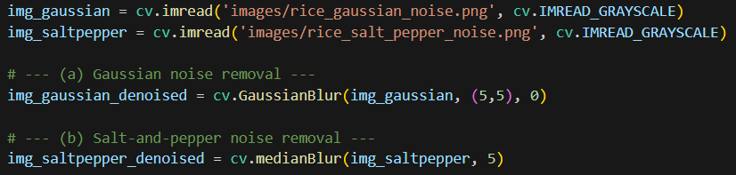

(c) Apply Otsu’s method to segment the image.

Convert denoised grayscale images to binary images to identify foreground and background. Otsu’s method automatically determines the best threshold.



(d) Apply morphological operations

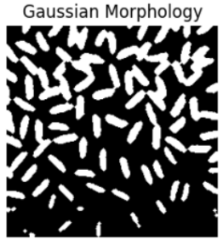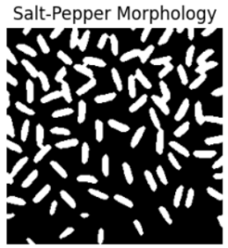Clean the binary images using morphological operations to removes small white noise pixels and fills small black holes inside foreground objects.

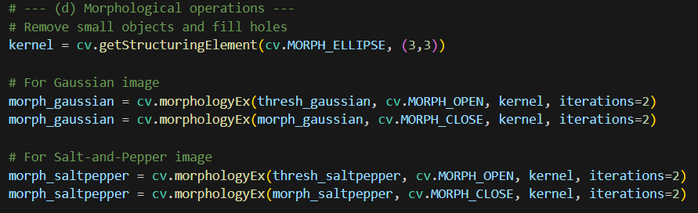

(e) Count the number of rice grains.

Identify connected regions (rice grains) in binary images. connectedComponents outputs num_labels which has the number of connected regions including background. Therefore, we subtract 1 because background is also counted.

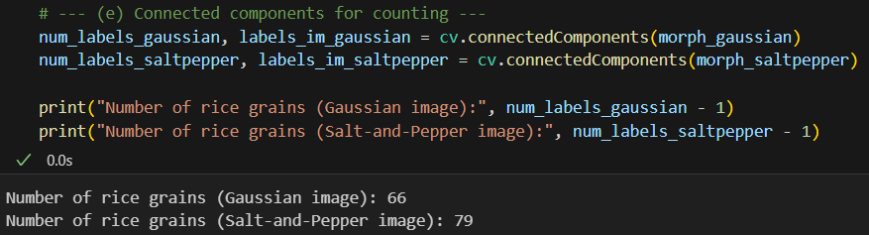

Number of rice grains (Gaussian image): 66  
Number of rice grains (Salt-and-Pepper image): 79

**Question 10**

1. Obtain a binary mask for the sapphires.

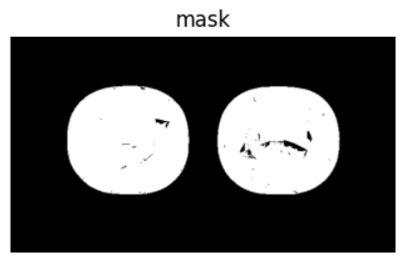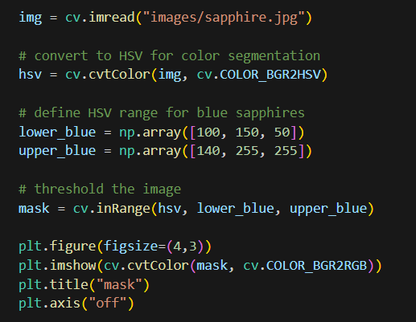A colour-based thresholding method was used to segment the image. The original image was converted to HSV color space. Then, the binary mask was created using a predefined HSV range for blue colour.

1. Apply a morphological operation to fill the holes

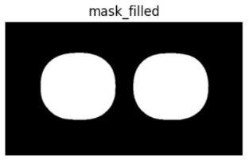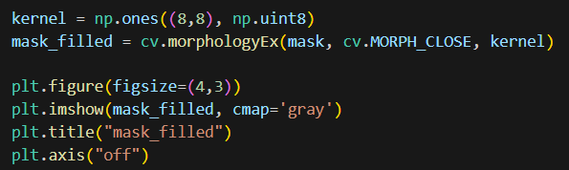To remove holes inside the sapphires, a morphological operation was used with kernel size 8. Because small kernel sizes (< 8) resulted unfilled few holes.

1. Run connectedComponentsWithStats to obtain the areas in pixels.

**Connected component labeling** was used to detect each sapphire separately. The **area in pixels** for each connected component (excluding background) was extracted from stats[:, cv.CC_STAT_AREA].

Areas in pixels: 30059 , 30042

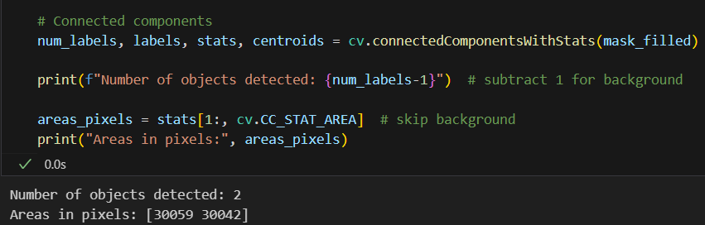

1. Compute the actual areas of the sapphires

The actual sapphire areas were computed using below equation.

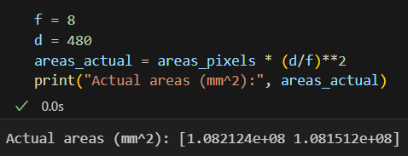 Area actual​ = Area pixels​ × (​)2

Actual areas = 1.082124e+08 mm2, 1.081512e+08 mm2

= 108212400 mm2, 108151200 mm2